CMPEN 271 Lab 2

Lab: Input-Output

September 16, 2019

Jefferson Bui

**Objective:**

Introduction to breadboard, wiring techniques, switches, LEDs, input and output circuits,

and integrated circuits (ICs). Construct circuit to with digital IC and test results.

**Materials:**

Breadboard

Wire kit

DIP 8-position switch

(3) 1Kohm resistors

7408 Quad AND Integrated circuit (IC)

(1) LED

DC Power Supply (set to 5 volts) or 9-volt battery with voltage regulator

Function generator

Oscilloscope

**Circuit Diagram:**

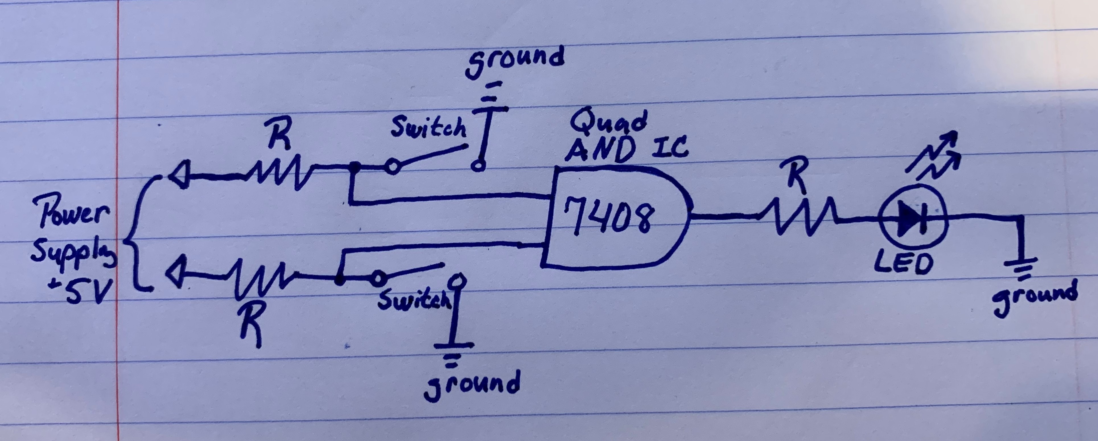

**Results:**

Initial Recorded Values:

Resistors to Switch: 5V

Resistor to LED: 1.8V

7408 Gate Output: 3.5V

Used AND gate inputs 1 & 2 output 3

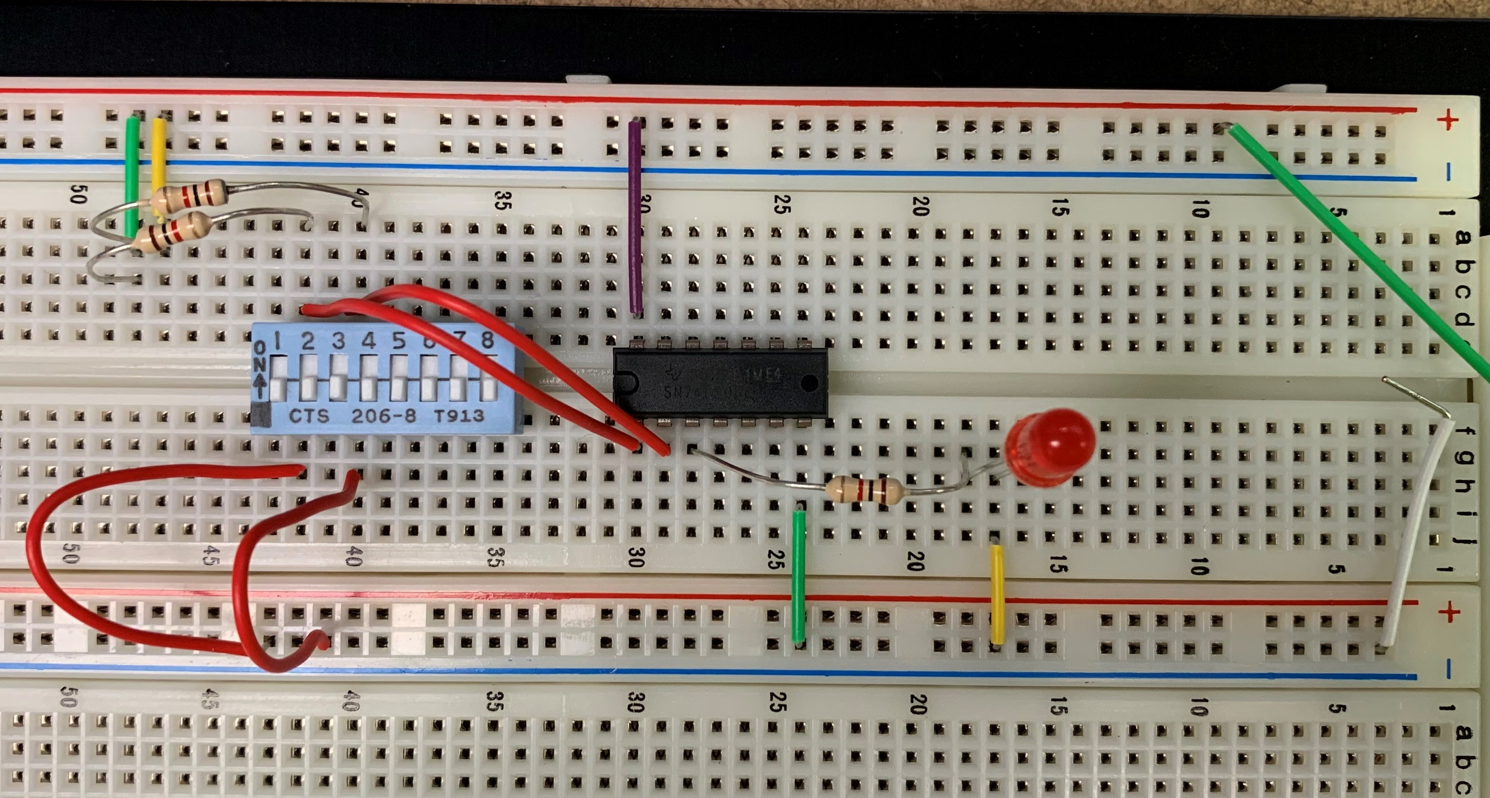

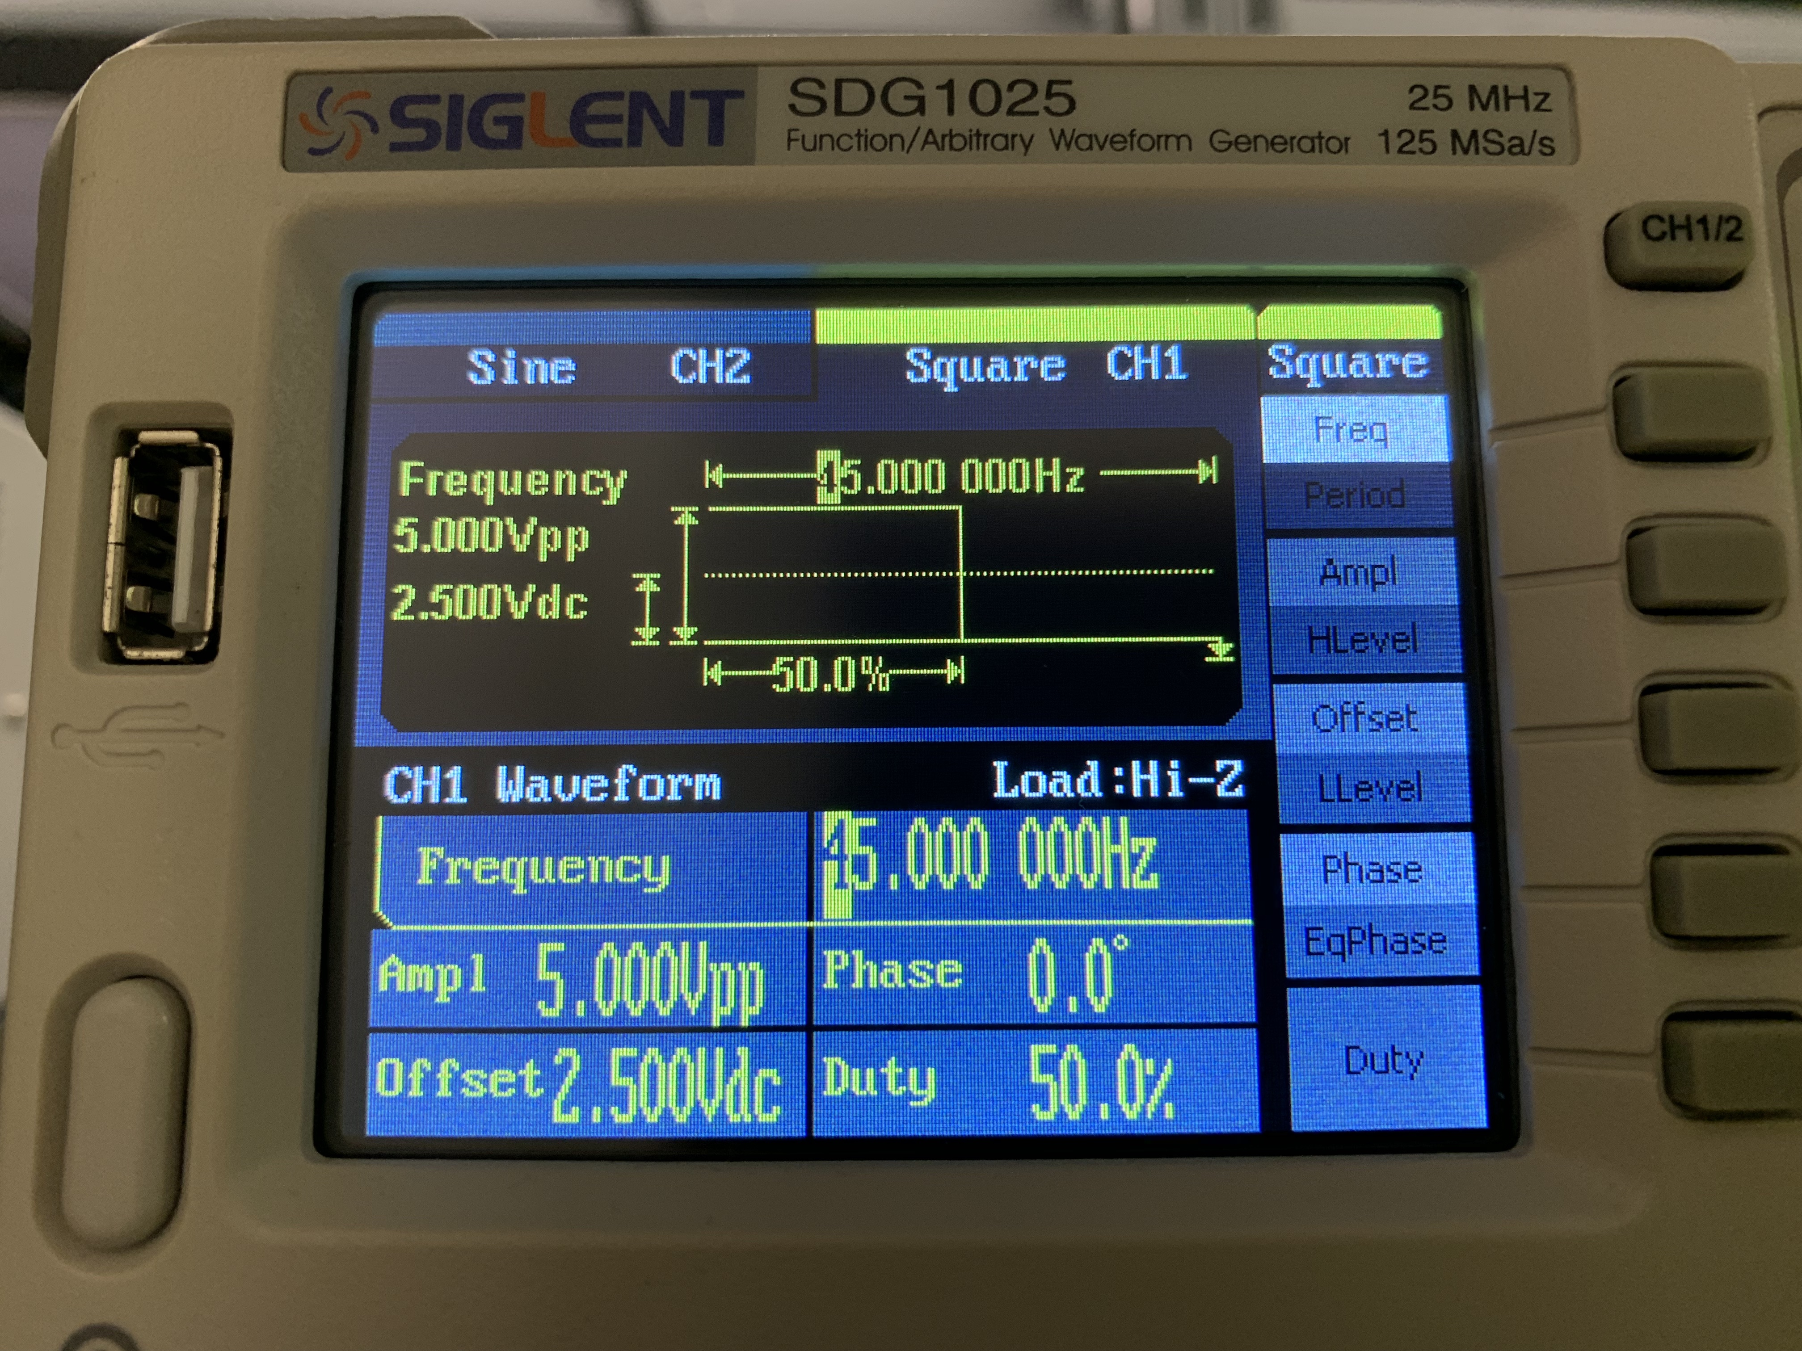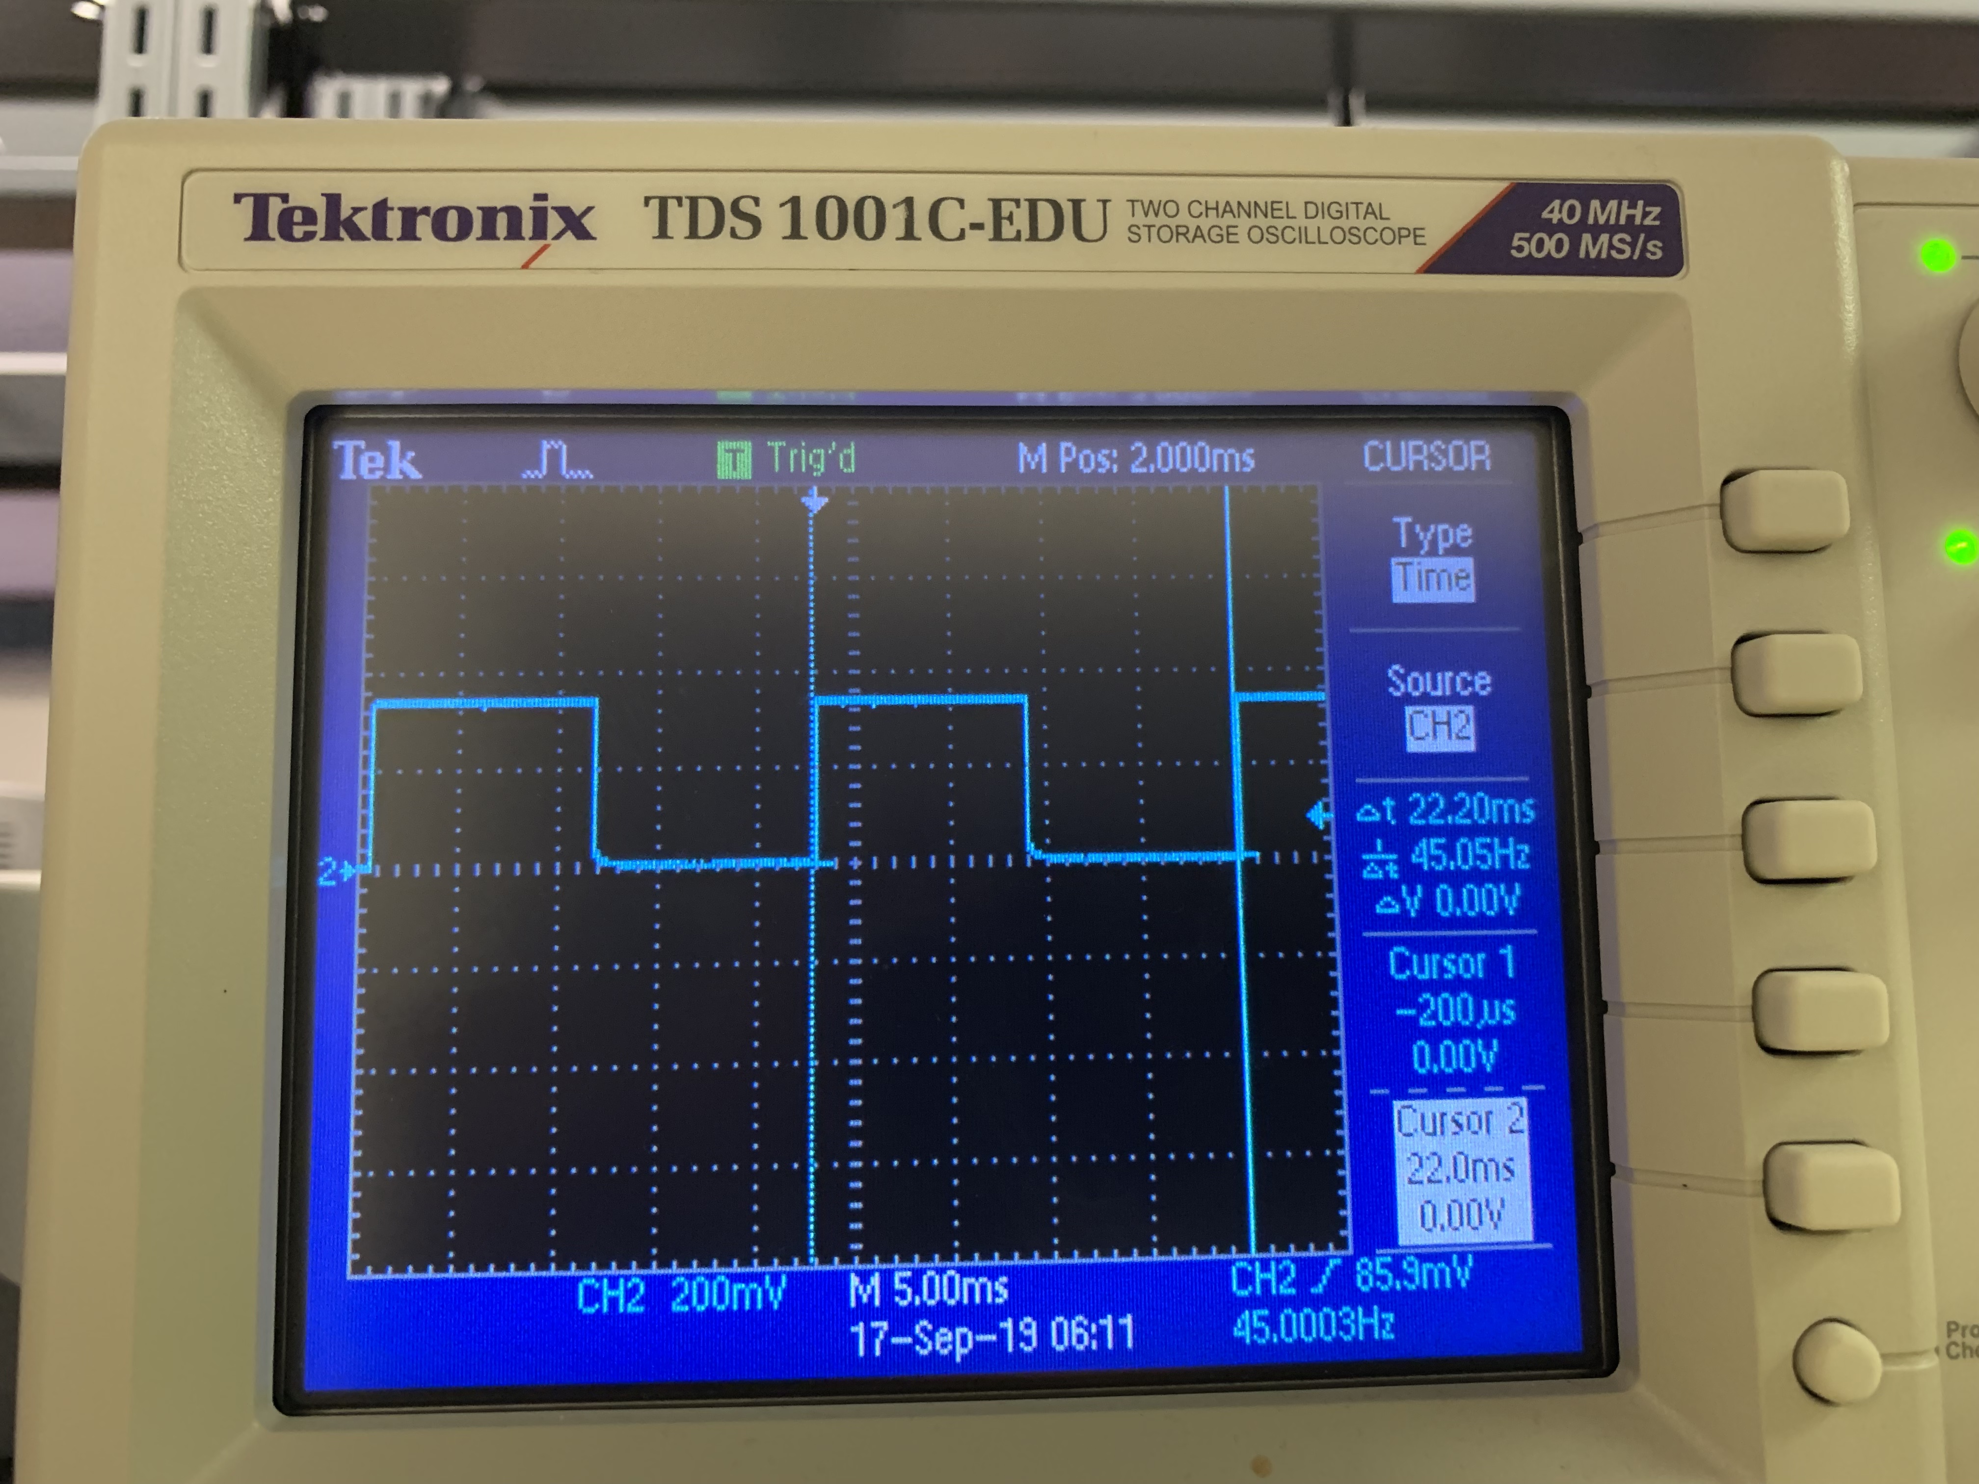

Frequency = 45Hz

Period = 22ms

**Questions & Answers:**

If input 2 is high, then LED is lit. If input 2 is low, then LED is not lit.

At about 45Hz the LED to the eye looks solid.

a) What is voltage of Vout in Figure 1 when switch is open? Explain

The voltage of Vout is 5V because the circuit doesn’t go to ground when the switch is open, so the voltage doesn’t change.

b) What is voltage of Vout in Figure 1 when switch is closed? Explain

The voltage of Vout is 0V because the circuit goes to ground. When the switch is close it connects the rest of the circuit together.